Big Oily could multiply existing reserves by 400% using available water technology.
By Kenneth M. Price, Jr. January 29, 2018
https://kenneth-m-price-jr.weebly.com/

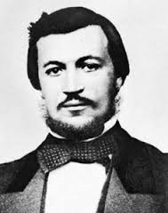
In 1885 a German engineer named Nikolaus Otto documented a quantum fuel improvement using 5% water and gasoline mixed together. Now, considering that Otto’s 4-cycle research is still taught in colleges and universities today, is it not odd that this part of his research is never mentioned?
Water and gasoline do not mix, right? What if you add a few drops of liquid laundry detergent into a one quart mix and shake it up? Now you see this white milky fluid. You have just made a cheap emulsion of water and gasoline.
Now, don’t put this in your engine!!! The viscosity is thicker than gasoline, so it won’t go through the fuel jet fast enough. However, if you hollowed out the fuel jet and/or heated the fuel before sending it to the carburetor, you would get an entirely different result. You see, in 1885 Nikolaus Otto documented that by adding 5% water, in the form of a stable emulsion, that the power output of the engine increased by about 25%! How is this possible, you ask?
The reason it works is so obvious the original inventor of the 4-stroke engine tested it from the get go. After all, what’s the main problem with a petrol powered piston engine? Heat! That’s because compressed gasoline vapors reach over 3,500 ⁰F during the combustion process.
In a gasoline combustion engine the only energy a piston-engine harnesses is the pressure from the combustion. It does not harness any of the heat. In fact it has to get rid of all of the heat generated or it will burn up! What a horrible design from a thermodynamic perspective this is! (That’s why Big Oily selected it!)
This is why improving a piston engine’s performance is as simple as boiling water on your stove. When some liquid H₂O goes into the combustion chamber, extra heat which would normally go out the tailpipe, turns the water into steam. And when water turns to steam it expands by 1,600 times. In this case it will expand even more as it goes into the “super-heat” phase immediately. This not only increases the combustion pressure but also decreases the exhaust gas temperature!! That means that now the engine is harnessing some of the heat from the combustion of gasoline. That is some darn good news!
Consider that there are many ways to tap into the miraculous properties of water. For example, water that has an extra Oxygen atom added to it, knowns as H₂O₂ (hydrogen peroxide), burns like rocket fuel. It was used along with N₂H₂ (hydrazine) to propel the 1944 Nazi rocket plane known as the Komet. This is just one demonstration of how water can be easily modified into a very combustible formula.
An even easier method, and one that is much safer, is to convert the water into methyl alcohol, also known as Methanol (CH₃OH). And the easiest way to accomplish this is to combine Water (H₂O) with Methane gas (CH₄) to produce Methanol: (CH₃OH). This reaction is briefly discussed below:
Steam reforming methane gas to produce methanol
The following was taken from an article in Marine Methanol, July 2016:
“Steam reforming is the dominant and traditional method where methane gas and steam is mixed at high temperature and pressure and with the help of catalysts form carbon monoxide and hydrogen (Equation 4). The gas mixture is typically led through pipes coated with catalysts in a tube in shell heat exchanger in order to provide the necessary heat (≈850 °C) for the reaction to take place.
Steam reforming 2CH₄ + 2H₂O ⇌ 2CO + 6H₂ ΔH_{298K}= 49.1 kcal/mol
Water gas shift CO + H₂O ⇌ CO₂ + H₂ ΔH_{298K}= -9.8 kcal/mol
Carbon dioxide is typically added to the gas mixture before the methanol synthesis but can also be present in the natural gas used as feedstock. One step steam reforming used to be the dominating process, but is today mainly considered for smaller plants up to 2500 MTPD where CO₂ is available at low cost or is present in the natural gas.”

The big caveat is this: Since Big Oily has the technology to break crude oil into gasoline, it also has the technology to break gasoline into Methane. So here is an industry secret that Big Oily does not want discussed; the fact that they could make alcohol from petroleum stocks plus water.
Thanks to recent research by Bruce McBurney (1954-2015) regarding the conversion of gasoline into methanol, the public now has access to the technology. You can read all of his research here: http://www.cyberclass.net/mcburney.htm
He shows that there are two water molecules required for every one molecule of gasoline in order to yield CH₄ (methane/natural gas) and CH₃OH (methanol). He then found a way to thermally crack gasoline using pressure, water and iron catalyst into methanol alcohol. The most startling part of the find was that the reaction produced 4.5 times as much fuel as he started with.
You are reading this correctly. In his tests conducted at the Chemistry Department at Brock University in Ontario one part gasoline with two parts water with an iron catalyst, cooked in a pressure vessel nearly identical to the catalytic cracking unit at every oil refinery and heated it to 500 ⁰C (932⁰F) produced Methanol plus a small amount of Methane. Again, the original amount of gasoline, multiplied by 4.5, equaled the amount of Methanol produced!
This is how we can use water technology to multiply existing petroleum stocks by 400% or more. It doesn’t surprise me to learn the creator has already provided an answer to our current toxic dilemma, but since we weren’t taught the full course in known water technology, we were stuck in our tracks. Today they should teach that at temperatures in the range of 500 to 920 ⁰C (932-1688 ⁰F) water (in the form of super-heated steam) becomes critical, and in this excited state water and gasoline molecules break apart.
Once these single bonds are broken, the carbon atoms bond with Hydrogen and OH molecules from the water. With this new knowledge it is obvious that all oil refineries should convert all gasoline into methyl alcohol before we burn it in our air. In fact, we should further extend the performance and savings by mixing it with water.
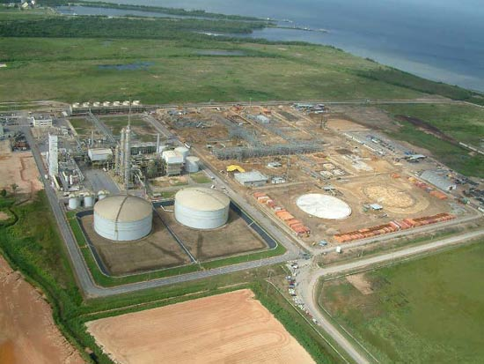
And so here we are today, ready to move out of the Dark Ages. We just need to go back to the refinery where gasoline is made and design and engineer the new technology. We just need to “inspire” the oil industry to get onboard with new technology that will make gasoline obsolete within weeks.
Realistically, the people need to organize a consortium of investors with the sole purpose of buying out a couple of major oil companies, like Exxon-Mobil. Then we could “persuade” their petroleum scientists to give us all of the formulas and manufacturing techniques they have already either designed or bought out. Oh, you don’t believe these formulas exist? Did the Germans have any problems finding ways to synthesize fuel in 1944 when they were cut off from many of their petroleum sources? I’ll bet you know the answer to that question.
Atlas Methanol Production Plant, Point Lisas, Trinidad and Tobago. "Average total methanol production from the plants is 2.5 million tpa, which makes it the world's leading methanol exporter."

Dear Personnel at Anti-Media,

The following is my most recent article exposing the Oil Industry-controlled Transportation mechanism, known as the "modern highway" for what it is; a hectic, unsafe fuel gobbling system only a psychotic-minded person would endorse. The portion of the article below is a well timed reminder that we can easily get out from under Big Oil the day we are allowed to use the water-hydrogen technology we've had since Prohibition. As it is right now, the public is being placated with self-drive technology and enhanced blue-tooth gadgetry when in fact the industry should be upgrading the fuel to a non-toxic one and building much smaller simpler engines. This is all layed out in my book here: https://the-rise-and-stall-of-the-piston-engine.weebly.com/

This new article is not yet published anywhere but you can view a similar one here: https://patriots4truth.org/2018/01/21/lindbergh-and-earhart-two-characters-one-man/

Here's the new article: If you're interested, I'll send you a pdf or word doc.

Sincerely, Kenneth M. Price, Jr

